Supplementary Content

Supplementary Table 1. Simone 10-point Grading Scale for Blink Reflex Assessment
Supplementary Table 2. Simone 10-point Grading Scale for Vibrissal Motor Function
Supplementary Table 3. Primers for mRNA and miRNA gene amplification by PCR
Supplementary Fig. 1. Representative brightfield microscopy images of cultured facial nucleus neurons from the control and iLIN28B groups

Supplementary Table 1. Simone 10-point Grading Scale for Blink Reflex Assessment.
Score | Blink Reflex | Eye Closure Status
1 | No Blink Reflex | Absent eye closure
2 | No Blink Reflex | 25% eye closure
3 | Present blink reflex | 50% eye closure
4 | Present blink reflex | 75% eye closure
5 | Normal | Complete

Supplementary Table 2. Simone 10-point Grading Scale for Vibrissal Motor Function.
Score | Vibrissal motor function | Vibrissal positioning
1 |  | Backward
  Absent whisker movement
2 | Mild tremor | Backward
3 | Pronounced tremor | Backward
4 | Normal whisker movement | Backward
5 | Normal | Forward

Supplementary Table 3. Primers for mRNA and miRNA gene amplification by PCR.
mRNA/miRNA Gene |  | Primers
Lin28a(fwd) | AATCCATCCGTGTCACTGGC
Lin28a(rev) | CTAGCCCACCGCAGTTGTAG
Lin28b(fwd) | AAAGGGAGATAGGTGGAGACG
Lin28b (rev) | TCCTGGACTCTTCTTCTCGC
let-7a(rt) | GTCGTATCCAGTGCAGGGTCCGAGGTATTCGCACTGGATACGACAACTATA
let-7a(fwd) | GCGGTGAGGTAGTAGGTTG
let-7b(rt) | GTCGTATCCAGTGCAGGGTCCGAGGTATTCGCACTGGATACGACAACCACA
let-7b(fwd) | GCGGTGAGGTAGTAGGTTG
let-7c(rt) | GTCGTATCCAGTGCAGGGTCCGAGGTATTCGCACTGGATACGACAACCATA
let-7c(fwd) | GCGGTGAGGTAGTAGGTTG
let-7d(rt) | GTCGTATCCAGTGCAGGGTCCGAGGTATTCGCACTGGATACGACAACTATG
let-7d(fwd) | GCGGAGAGGTAGTAGGTTG
let-7e(rt) | GTCGTATCCAGTGCAGGGTCCGAGGTATTCGCACTGGATACGACAACTATA
let-7e(fwd) | GCGTGAGGTAGGAGGTTG
let-7f(rt) | GTCGTATCCAGTGCAGGGTCCGAGGTATTCGCACTGGATACGACAACTATA
let-7f(fwd) | GCGCGTGAGGTAGTAGATTG
let-7g(rt) | GTCGTATCCAGTGCAGGGTCCGAGGTATTCGCACTGGATACGACAACTGTA
let-7g(fwd) | GCGCGTGAGGTAGTAGTTTG
let-7i(rt) | GTCGTATCCAGTGCAGGGTCCGAGGTATTCGCACTGGATACGACAACAGCA
let-7i(fwd) | GCGCGTGAGGTAGTAGTTTG
Universal miRNA (rev) | GCAGGGTCCGAGGTATTC
Rpl19(fwd) | GCATCCTCATGGAGCACAT
Rpl19(rev) | CTGGTCAGCCAGGAGCTT
fwd, forward primer. rev, reverse primer. rt, reverse transcription primer.

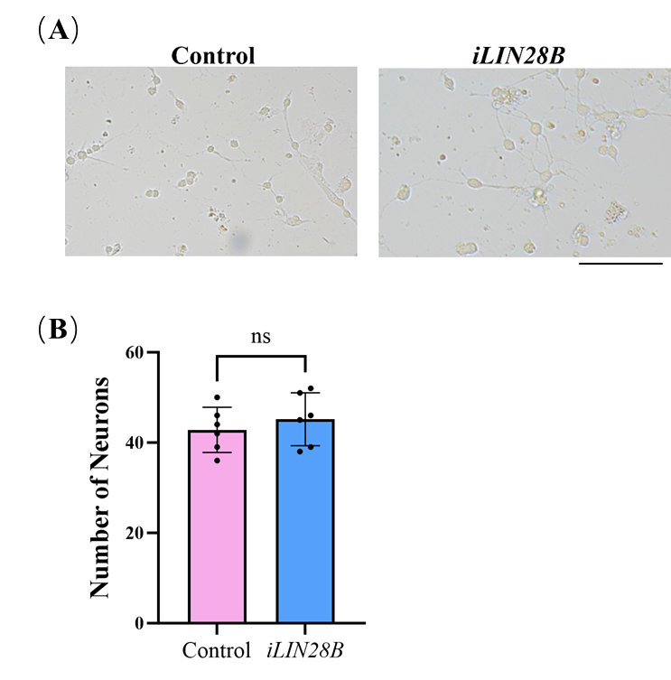

Supplementary Fig. 1. Representative brightfield microscopy images of cultured facial nucleus neurons from the control and iLIN28B groups. Statistical significance was assessed by unpaired two-tailed Student's t-tests. Scale bar = 100 µm.

